Joel Atkinson
February 14, 2026
CSD430 Server Side Development
Assignment 7.2

Updated index.jsp code with newly added Assignment part 2:
<%@ page contentType="text/html; charset=UTF-8" pageEncoding="UTF-8" %>
<!DOCTYPE html>
<html lang="en">
<head>
<meta charset="UTF-8">
<meta name="viewport" content="width=device-width, initial-scale=1.0">
<title>CSD430 - Server Side Development</title>
<link rel="stylesheet" href="<%=request.getContextPath()%>/index.css">
</head>
<body>
<div class="page">
<div class="header">
<h1>CSD430 - Server Side Development</h1>
<p>This index page contains links to all module assignments for this course.</p>
</div>
<hr class="gold-divider">
<div class="content">
<h2>Assignments</h2>
<div class="assignments">
<ul>
<li>
<a class="assignment-link" href="selectState.jsp">
<span class="assignment-title">
Assignment Part 1 - State Database Lookup
</span>
<span class="assignment-desc">
State Record Display
</span>
</a>
</li>
<%-- Adding in link and description to my index page for Part 2 of Assignment --%>
<li>
<a class="assignment-link" href="addState.jsp">
<span class="assignment-title">
Assignment Part 2 - Add State Record
</span>
<span class="assignment-desc">
Insert New State Into Database
</span>
</a>
</li>
</ul>
</div>
</div>
<hr class="footer-divider">
<div class="footer">
<p>© Joel Atkinson</p>
<p>Bellevue University</p>
<p>2026</p>
</div>
</div>
</body>
</html>

Updated CSS code:
* {
box-sizing: border-box;
}
html, body {
height: 100%;
margin: 0;
padding: 0;
}
body {
font-family: Arial, sans-serif;
background-color: #eaeaea;
color: #000;
line-height: 1.6;
}
.page {
min-height: 100vh;
display: flex;
flex-direction: column;
}
/* Header */
.header {
background-color: #5b2c83;
padding: 40px 20px;
text-align: center;
}
.header h1 {
color: #DAA520;
margin: 0 0 12px 0;
font-size: 2.4em;
}
.header p {
color: white;
max-width: 900px;
margin: 0 auto;
font-size: 1.1em;
}
.gold-divider {
border: none;
height: 4px;
background-color: #DAA520;
margin: 0;
}
.content {
flex: 1 0 auto;
background-color: white;
padding: 40px 20px;
}
.form-card {
max-width: 1100px;
margin: 0 auto;
padding: 24px 22px;
border-radius: 10px;
border: 2px solid #5b2c83;
box-shadow: 0 4px 8px rgba(0,0,0,0.08);
background-color: white;
}
label {
font-weight: bold;
color: #5b2c83;
display: block;
margin-bottom: 6px;
}
select {
width: 100%;
padding: 10px 12px;
border-radius: 8px;
border: 2px solid #5b2c83;
font-size: 1em;
margin-bottom: 18px;
}
.button-row {
text-align: center;
}
button {
background-color: #5b2c83;
color: #DAA520;
border: none;
border-radius: 8px;
padding: 11px 24px;
font-size: 1em;
font-weight: bold;
cursor: pointer;
}
button:hover {
background-color: #DAA520;
color: #5b2c83;
box-shadow: #5b2c83 0 0 6px 2px;
}
.footer-divider {
border: none;
height: 4px;
background-color: #5b2c83;
margin: 0;
}
.footer {
background-color: white;
color: #5b2c83;
text-align: center;
padding: 16px 20px;
font-size: 0.95em;
font-weight: 600;
flex-shrink: 0;
}
.footer p {
margin: 4px 0;
}
.footer-divider {
border: none;
height: 4px;
background-color: #5b2c83;
margin: 0;
}
.assignment-footer {
background-color: white;
color: #5b2c83;
text-align: center;
padding: 16px 20px;
font-size: 0.95em;
font-weight: 600;
flex-shrink: 0;
}
.assignment-footer p {
margin: 4px 0;
text-align: center;
}
.state-table {
width: 100%;
border-collapse: collapse;
margin-top: 16px;
table-layout: auto;
}
.state-table th,
.state-table td {
border: 2px solid #5b2c83;
padding: 10px 12px;
text-align: left;
font-size: 0.95em;
overflow-wrap: break-word;
word-break: break-word;
max-width: 0;
width: auto;
}
.state-table th {
background-color: #5b2c83;
color: #DAA520;
font-weight: bold;
}
.state-table td {
background-color: #ffffff;
color: #000;
white-space: normal;
}
.form-card {
overflow-x: auto;
}
.link-button {
display: inline-block;
background-color: transparent;
color: #5b2c83;
text-decoration: none;
border-radius: 8px;
padding: 10px 20px;
font-size: 1em;
font-weight: bold;
}
.link-button:hover {
box-shadow: #5b2c83 0 0 6px 2px;
}
.link-split {
display: flex;
justify-content: space-between;
align-items: center;
width: 85%;
margin: 24px auto 0 auto;
}

Updated StatesBean code:
package beans;
import java.sql.*;
import java.util.ArrayList;
import java.util.List;
/* Joel Atkinson, February 14, 2026 CSD430 Server Side Development Assignment 5&6 UPDATED BEAN CODE
The purpose of this assignment is to create a database called CSD430 in SQL, then create a table (I chose U.S. states),
and populate that table with at least 5 data fields. From there create a JavaBean to pull the data from the database
which will be linked to the .jsp files in order to have a selection of a U.S. state and then to display the data of that
state in a table. In addition to this, also create an index.jsp file for this course as the landing page where all of our
assignments will be held. I went ahead and also created .css style sheets for both the index as well as the module 5/6
.jsp files. */
public class StatesBean {
private static final String JDBC_URL = "jdbc:mysql://localhost:3306/CSD430?useSSL=false&serverTimezone=UTC";
private static final String JDBC_USER = "student1";
private static final String JDBC_PASS = "pass";
private static final String JDBC_DRIVER = "com.mysql.cj.jdbc.Driver";
static {
try {
Class.forName(JDBC_DRIVER);
} catch (ClassNotFoundException e) {
e.printStackTrace();
}
}
private Connection getConnection() throws SQLException {
return DriverManager.getConnection(JDBC_URL, JDBC_USER, JDBC_PASS);
}
public static class StateOption {
public final int id;
public final String name;
public StateOption(int id, String name) {
this.id = id;
this.name = name;
}
}
public static class StateRecord {
public int id;
public String stateCode;
public String stateName;
public String capital;
public String region;
public Long population;
public Integer yearFounded;
}
public List<StateOption> getStateOptions() {
List<StateOption> options = new ArrayList<>();
String sql = "SELECT id, state_name FROM Joel_states_data ORDER BY state_name";
try (Connection conn = getConnection();
PreparedStatement ps = conn.prepareStatement(sql);
ResultSet rs = ps.executeQuery()) {
while (rs.next()) {
options.add(new StateOption(
rs.getInt("id"),
rs.getString("state_name")
));
}
} catch (SQLException e) {
e.printStackTrace();
}
return options;
}
public StateRecord getStateById(int id) {
String sql = "SELECT id, state_code, state_name, capital, region, population, year_founded " +
"FROM Joel_states_data WHERE id = ?";
try (Connection conn = getConnection();
PreparedStatement ps = conn.prepareStatement(sql)) {
ps.setInt(1, id);
try (ResultSet rs = ps.executeQuery()) {
if (rs.next()) {
StateRecord s = new StateRecord();
s.id = rs.getInt("id");
s.stateCode = rs.getString("state_code");
s.stateName = rs.getString("state_name");
s.capital = rs.getString("capital");
s.region = rs.getString("region");
long popVal = rs.getLong("population");
s.population = rs.wasNull() ? null : popVal;
int yf = rs.getInt("year_founded");
s.yearFounded = rs.wasNull() ? null : yf;
return s;
}
}
} catch (SQLException e) {
e.printStackTrace();
}
return null;
}
public List<StateRecord> getAllStates() {
List<StateRecord> states = new ArrayList<>();
String sql = "SELECT id, state_code, state_name, capital, region, population, year_founded " +
"FROM Joel_states_data ORDER BY state_name";
try (Connection conn = getConnection();
PreparedStatement ps = conn.prepareStatement(sql);
ResultSet rs = ps.executeQuery()) {
while (rs.next()) {
StateRecord s = new StateRecord();
s.id = rs.getInt("id");
s.stateCode = rs.getString("state_code");
s.stateName = rs.getString("state_name");
s.capital = rs.getString("capital");
s.region = rs.getString("region");
long popVal = rs.getLong("population");
s.population = rs.wasNull() ? null : popVal;
int yf = rs.getInt("year_founded");
s.yearFounded = rs.wasNull() ? null : yf;
states.add(s);
}
} catch (SQLException e) {
e.printStackTrace();
}
return states;
}
public boolean addStateRecord(String stateName,
String stateCode,
String capital,
String region,
Long population,
Integer yearFounded) {
String sql = "INSERT INTO Joel_states_data " +
"(state_name, state_code, capital, region, population, year_founded) " +
"VALUES (?, ?, ?, ?, ?, ?)";
try (Connection conn = getConnection();
PreparedStatement ps = conn.prepareStatement(sql)) {
ps.setString(1, stateName);
ps.setString(2, stateCode);
ps.setString(3, capital);
ps.setString(4, region);
if (population == null) {
ps.setNull(5, Types.BIGINT);
} else {
ps.setLong(5, population);
}
if (yearFounded == null) {
ps.setNull(6, Types.INTEGER);
} else {
ps.setInt(6, yearFounded);
}
return ps.executeUpdate() == 1;
} catch (SQLException e) {
e.printStackTrace();
return false;
}
}
}

addState.jsp code:
<%-- Joel Atkinson, February 14, 2026, CSD430 Server Side Development Assignment 7.2. The purpose of this assignment
is to update my javabean to allow for data to be added into the database through a form that I also created using .jsp
this form will allow users to add a state to the database and then will proceed to show the user the entire database with
the newly added state date in there. --%>
<%@ page contentType="text/html; charset=UTF-8" pageEncoding="UTF-8" %>
<!DOCTYPE html>
<html lang="en">
<head>
<meta charset="UTF-8">
<title>Add State Record</title>
<link rel="stylesheet" href="assignment_5_1.css">
</head>
<body>
<div class="page">
<div class="header">
<h1>Add a State Record</h1>
<p>Enter state information below to add a new record to the database.</p>
</div>
<hr class="gold-divider">
<div class="content">
<div class="form-card">
<form action="processAddState.jsp" method="post">
<label for="state_name">State Name:</label>
<input type="text" id="state_name" name="state_name" required>
<label for="state_code">State Code (2 letters):</label>
<input type="text" id="state_code" name="state_code" maxlength="2" required>
<label for="capital">Capital:</label>
<input type="text" id="capital" name="capital" required>
<label for="region">Region</label>
<select name="region" id="region" required>
<option value="">-- Select Region --</option>
<option value="Midwest">Midwest</option>
<option value="Northeast">Northeast</option>
<option value="Pacific Northwest">Pacific Northwest</option>
<option value="Southeast">Southeast</option>
<option value="Southwest">Southwest</option>
<option value="West">West</option>
</select>
<label for="population">Population:</label>
<input type="number" id="population" name="population" min="0" required>
<label for="year_founded">Year Founded:</label>
<input type="number" id="year_founded" name="year_founded" min="0" required>
<div class="button-row">
<button type="submit">Add State</button>
</div>
</form>
</div>
</div>
<hr class="footer-divider">
<div class="footer">
<p>© Joel Atkinson</p>
<p>Bellevue University</p>
<p>2026</p>
</div>
</div>
</body>
</html>

processAddState.jsp code:
<%-- Joel Atkinson, February 14, 2026, CSD430 Server Side Development Assignment 7.2. The purpose of this assignment
is to update my javabean to allow for data to be added into the database through a form that I also created using .jsp
this form will allow users to add a state to the database and then will proceed to show the user the entire database with
the newly added state date in there. --%>
<%@ page contentType="text/html; charset=UTF-8" pageEncoding="UTF-8" %>
<%@ page import="beans.StatesBean" %>
<%@ page import="java.util.List" %>
<%@ page import="beans.StatesBean.StateRecord" %>
<!DOCTYPE html>
<html lang="en">
<head>
<meta charset="UTF-8">
<title>All State Records</title>
<link rel="stylesheet" href="assignment_5_1.css">
</head>
<body>
<div class="page">
<div class="header">
<h1>All State Records</h1>
<p>Below are all records currently stored in the database table.</p>
</div>
<hr class="gold-divider">
<div class="content">
<%
// Read form values
String stateName = request.getParameter("state_name");
String stateCode = request.getParameter("state_code");
String capital = request.getParameter("capital");
String region = request.getParameter("region");
Long population = Long.parseLong(request.getParameter("population"));
Integer yearFounded = Integer.parseInt(request.getParameter("year_founded"));
// Insert record
StatesBean bean = new StatesBean();
boolean added = bean.addStateRecord(stateName, stateCode.toUpperCase(), capital, region, population, yearFounded);
// Fetch all records for display
List<StateRecord> states = bean.getAllStates();
%>
<div class="form-card">
<%
if (added) {
%>
<p><strong>Success!</strong> The new state record was added.</p>
<%
} else {
%>
<p><strong>Error:</strong> The record could not be added. Please try again.</p>
<%
}
%>
<table class="state-table">
<thead>
<tr>
<th>ID</th>
<th>State Name</th>
<th>State Code</th>
<th>Capital</th>
<th>Region</th>
<th>Population</th>
<th>Year Founded</th>
</tr>
</thead>
<tbody>
<% for (StateRecord s : states) { %>
<tr>
<td><%= s.id %></td>
<td><%= s.stateName %></td>
<td><%= s.stateCode %></td>
<td><%= s.capital %></td>
<td><%= s.region %></td>
<td><%= s.population %></td>
<td><%= s.yearFounded %></td>
</tr>
<% } %>
</tbody>
</table>
<div class="link-row">
<a class="link-button" href="addState.jsp">Add Another State</a>
<a class="link-button" href="index.jsp">Back to Index</a>
</div>
</div>
</div>
<hr class="footer-divider">
<div class="footer">
<p>© Joel Atkinson</p>
<p>Bellevue University</p>
<p>2026</p>
</div>
</div>
</body>
</html>

Screenshot of index.jsp output with new assignment:
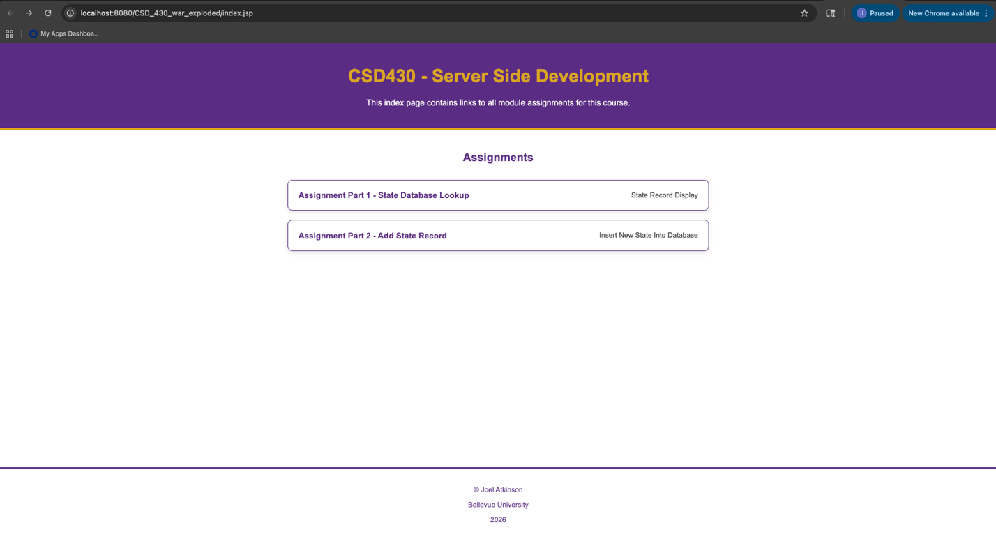

Screenshot of addState output (with me adding Alaska to database):
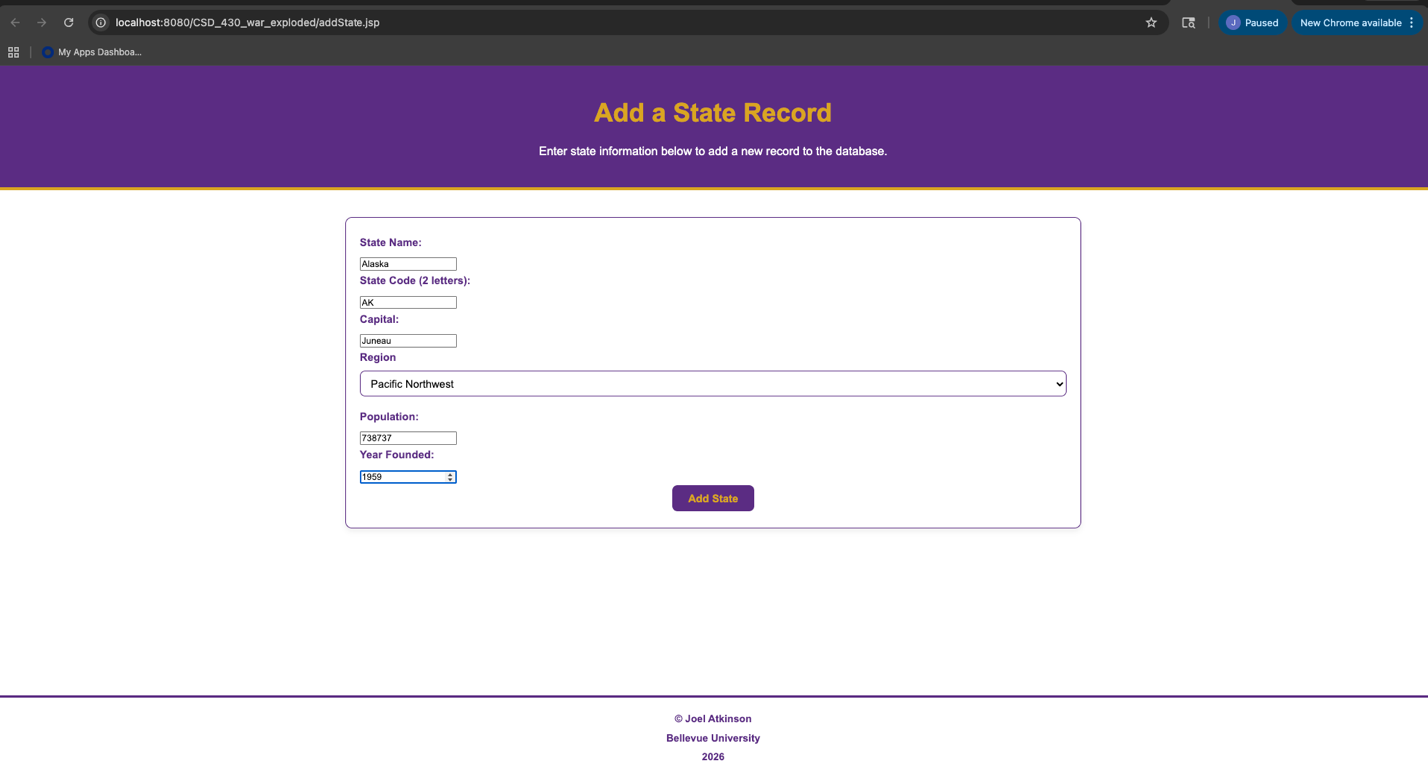

Screenshot of the chart displaying all of the data in my states database including the newly added Alaska:
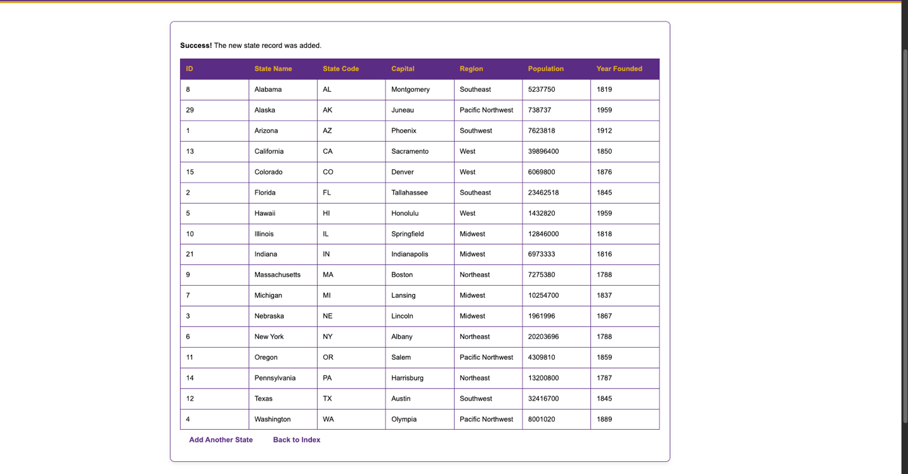

Screenshot of my SQL Terminal showing that Alaska was in fact added:
